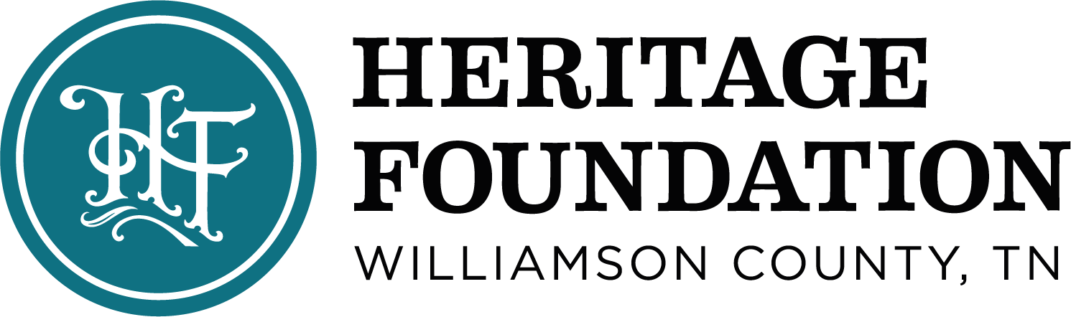
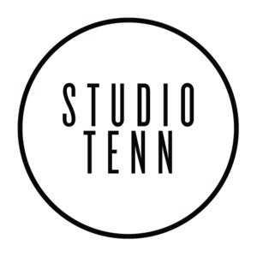

FOR IMMEDIATE RELEASE
STUDIO TENN CONTACT: HERITAGE FOUNDATION CONTACT:
William Guice Carla Denham
williamguice@studiotenn.com cdenham@williamsonheritage.org
Studio Tenn Joins Forces with the Heritage Foundation to host Nationally Recognized Studio Tenn Talks Live from The Franklin Theatre in 2021
Virtual talk show series to be streamed live from The Franklin Theatre stage
FRANKLIN – Studio Tenn, the Franklin-based professional regional theatre company and the Heritage Foundation of Williamson County, TN, parent company of The Franklin Theatre, are excited to announce that the popular talk show series, Studio Tenn Talks: Theatre Conversations with Patrick Cassidy, will begin its 2021 virtual broadcast from the stage of The Franklin Theatre.

Kicking off the 2021 season will be award-winning actress and singer, Kristin Chenoweth, whose resume spans theater, film and television. She is best known for her role as Glinda the Good Witch in the popular Broadway musical, Wicked. The first show will be broadcast live at 7 p.m. February 1, on Studio Tenn’s YouTube channel and at www.studiotenntalks.com.

Also new for the Studio Tenn Talks upcoming season is the addition of musical director Patrick Thomas, who is an accomplished musician and a former contestant on The Voice.

“We are so blessed to have him be a part of this show,” said Studio Tenn Artistic Director Patrick Cassidy. “He is a musical director extraordinaire as well as a great artist, musician and singer in his own right. He will add a big component to the experience of the show.”
All non-profits, Studio Tenn, the Heritage Foundation and The Franklin Theatre, have had to pivot during the 2020 pandemic season and were able to partner to give show host and Studio Tenn Cassidy a place to continue the nationally recognized talk show. This also marks the first phase of the theater’s reopening strategy, with a focus on small, private events and productions.
“We are so excited to be bringing this virtual broadcast to the stage at the beloved Franklin Theatre,” Cassidy said. “Because we had to pause our 2020/2021 performance season, we are more excited than ever to be able to continue this talk show in a virtual format from such an amazing historic venue.”

Studio Tenn Talks has featured interviews with Broadway, film and music stars such as Patti LuPone, Jason Alexander, Debbie Gibson and Michael Feinstein. All of the past Studio Tenn Talks shows can be viewed on the theatre company’s YouTube channel HERE.

Bari Beasley, CEO of the Heritage Foundation, said this partnership is the result of some creative thinking during a challenging time that will be a great addition to the theater’s lineup.

“One of our goals for the theater in 2020 and beyond was to maintain the type of shows that have made this theater so great, but also to bolster that with diversity in programming,” she said. “This partnership with Studio Tenn is a great example of ways the theater can be home to a broader audience than in the past to include theatrical performances and free programming. We are excited to have this amazing theater group host this show from our stage. We can’t wait to see how their season comes together in 2021.”
Studio Tenn Talks: Theater Conversations with Patrick Cassidy will take place every Monday at 7 p.m. CST and can be viewed at studiotenntalks.com or on the Facebook page, facebook.com/studiotenntheatrecompany. The show is free for all viewers, and voluntary donations are accepted.
The 2021 season is still being booked, but guests confirmed to date include:
2/1 Kristin Chenoweth
2/8 Norm Lewis
2/15 John Stamos
2/22 Susan Egan & Sierra Boggess

ABOUT STUDIO TENN
STUDIO TENN is a professional regional theater company and a 501(c)3 nonprofit organization based in Franklin, Tenn. Its programming centers around innovative, custom-designed presentations of classic plays and musicals as well as an original “Legacy” series of theatrical concerts celebrating the work of time-honored musicians. Learn more at studiotenn.com.
ABOUT THE HERITAGE FOUNDATION OF WILLIAMSON COUNTY
Since 1967, the Heritage Foundation of Williamson County has been dedicated to preserving Williamson County’s architectural, geographic and cultural heritage as well as promoting the ongoing revitalization of downtown Franklin in the context of historic preservation. Notable projects include The Franklin Theatre, Roper’s Knob, parts of the Franklin battlefield and the Old, Old Jail. The Foundation brings county history to about 3,000 school children each year through the Heritage Classroom program as well as walking tours of downtown Franklin. Events and festivals produced by the Heritage Foundation such as Main Street Festival, the Heritage Ball, Pumpkinfest and Dickens of a Christmas bring hundreds of thousands of locals and visitors to downtown Franklin each year. The Heritage Foundation owns and operates The Franklin Theatre, the Downtown Franklin Association, and the organization’s newest division and current restoration project, Franklin Grove Estate & Gardens. For more information about the Heritage Foundation, visit www.williamsonheritage.org.
ABOUT THE FRANKLIN THEATRE
Following a complete restoration by the Heritage Foundation of Williamson County, TN, in 2011, the historic Franklin Theatre (Est. 1937), re-opened its doors as a state-of-the-art live music venue featuring performances by world-renowned artists. The theater also honors its heritage by continuing to show movies. The theater’s mission is to provide world-class, diverse performing arts experiences to residents and visitors alike and to be a platform for local philanthropic engagement and education, all delivered with unparalleled guest service.
For more information about The Franklin Theatre, visit www.franklintheatre.com.

PHOTO CAPTION:
Patrick Cassidy, artistic director for Studio Tenn, stands in front of The Franklin Theatre, where his popular show, Studio Tenn Talks: Theater Conversations with Patrick Cassidy will be streamed live beginning February 1.

# # #

